The Federated Full-Stack: A High-Performance Architectural Blueprint (2026 Edition)

1. The Architectural Shift: From Monolith to Federation
The trajectory of web application architecture has undergone a decisive fracture in the mid-2020s. The industry has moved away from the "Backend-as-a-Service" (BaaS) lock-in model, typified by early Firebase or strictly homogeneous stacks, toward a model best described as the Federated Full-Stack. In this paradigm, the monolithic backend is dismantled into specialized, best-in-class infrastructure providers that are loosely coupled via open standards (OIDC, SQL, REST/gRPC) but tightly integrated at the edge. The technology stack under analysis—comprising TanStack, Supabase, Clerk, Netlify, Cloudflare R2, Capacitor, Zod, Apache Iceberg, Motion for React, ThorVG, Shadcn, Tailwind, Stripe, and OpenAI / DeepL—represents the apex of this architectural evolution.
This report serves as a rigorous technical specification for a Senior Technical Lead or Systems Architect. It moves beyond feature enumeration to analyze the connective tissue of this stack: the specific cryptographic handshakes between Clerk and Supabase, the data serialization contracts enforced by Zod across Deno edge runtimes, and the economic arbitrage of moving analytical workloads from Postgres heap storage to Cloudflare R2 object storage via Apache Iceberg.
The architecture segregates concerns into four distinct planes. First, the Client Plane (React, Capacitor, ThorVG) handles state and rendering with a focus on eliminating network waterfalls. Second, the Identity Plane (Clerk) manages the increasingly complex regulatory and security landscape of user sovereignty, decoupling auth from the database. Third, the Edge Plane (Netlify, Supabase Functions) acts as the intelligent glue, routing traffic and enforcing security boundaries before requests touch the core. Finally, the Data Plane implements a hybrid storage model, leveraging Supabase for high-concurrency transactional (OLTP) workloads and Apache Iceberg on R2 for high-volume analytical (OLAP) storage, all unified under a single SQL interface.
The subsequent sections will deconstruct each of these planes, providing an exhaustive analysis of configuration strategies, performance implications, and integration patterns necessary to deploy this stack at scale.

2. Identity and Sovereignty: The Clerk-Supabase Nexus
The integration of Clerk for identity management and Supabase for persistence marks a departure from the traditional "Supabase Auth" all-in-one approach. While Supabase provides a competent authentication service based on GoTrue, splitting identity (Clerk) from resources (Supabase) allows for a "best-of-breed" strategy. Clerk specializes in the high-friction "front door" problems—MFA, B2B multi-tenancy, and localized compliance—while Supabase reverts to its strongest role: a high-performance, RLS-protected Postgres engine.

2.1 The Native OIDC Integration Architecture
Historically, integrating Clerk with Supabase was a brittle process relying on "JWT Templates." Developers were forced to generate a symmetric HS256 signing secret in Supabase and paste it into Clerk. This shared-secret model posed a significant security risk; if the signing key were compromised on either end, an attacker could forge tokens with full admin privileges.¹ Furthermore, this method required manual token rotation and created synchronization headaches across environments.
As of April 2025, the architectural standard has shifted to a Native Third-Party Integration model.² This new pattern leverages Supabase's capability to act as an OIDC Resource Server that establishes a trust relationship with Clerk as an external Identity Provider (IdP).

Cryptographic Trust Establishment
In this modern configuration, the shared secret is eliminated. Instead, the trust is established via asymmetric cryptography (RS256).
- Issuer Discovery: Supabase is configured with Clerk's Issuer URL (e.g., https://clerk.your-domain.com).
- Key Fetching: Supabase periodically polls Clerk's /.well-known/jwks.json endpoint to retrieve the public keys used to sign session tokens.³
- Token Validation: When a request arrives at the Supabase Data API (PostgREST), the system inspects the kid (Key ID) header of the JWT. It matches this against the cached public keys from Clerk to verify the signature.
This architecture ensures that Supabase never needs access to Clerk's private signing keys, adhering to the principle of least privilege. It also simplifies key rotation; Clerk can rotate its signing keys automatically, and Supabase will simply fetch the new public keys via the JWKS endpoint without manual intervention or downtime.

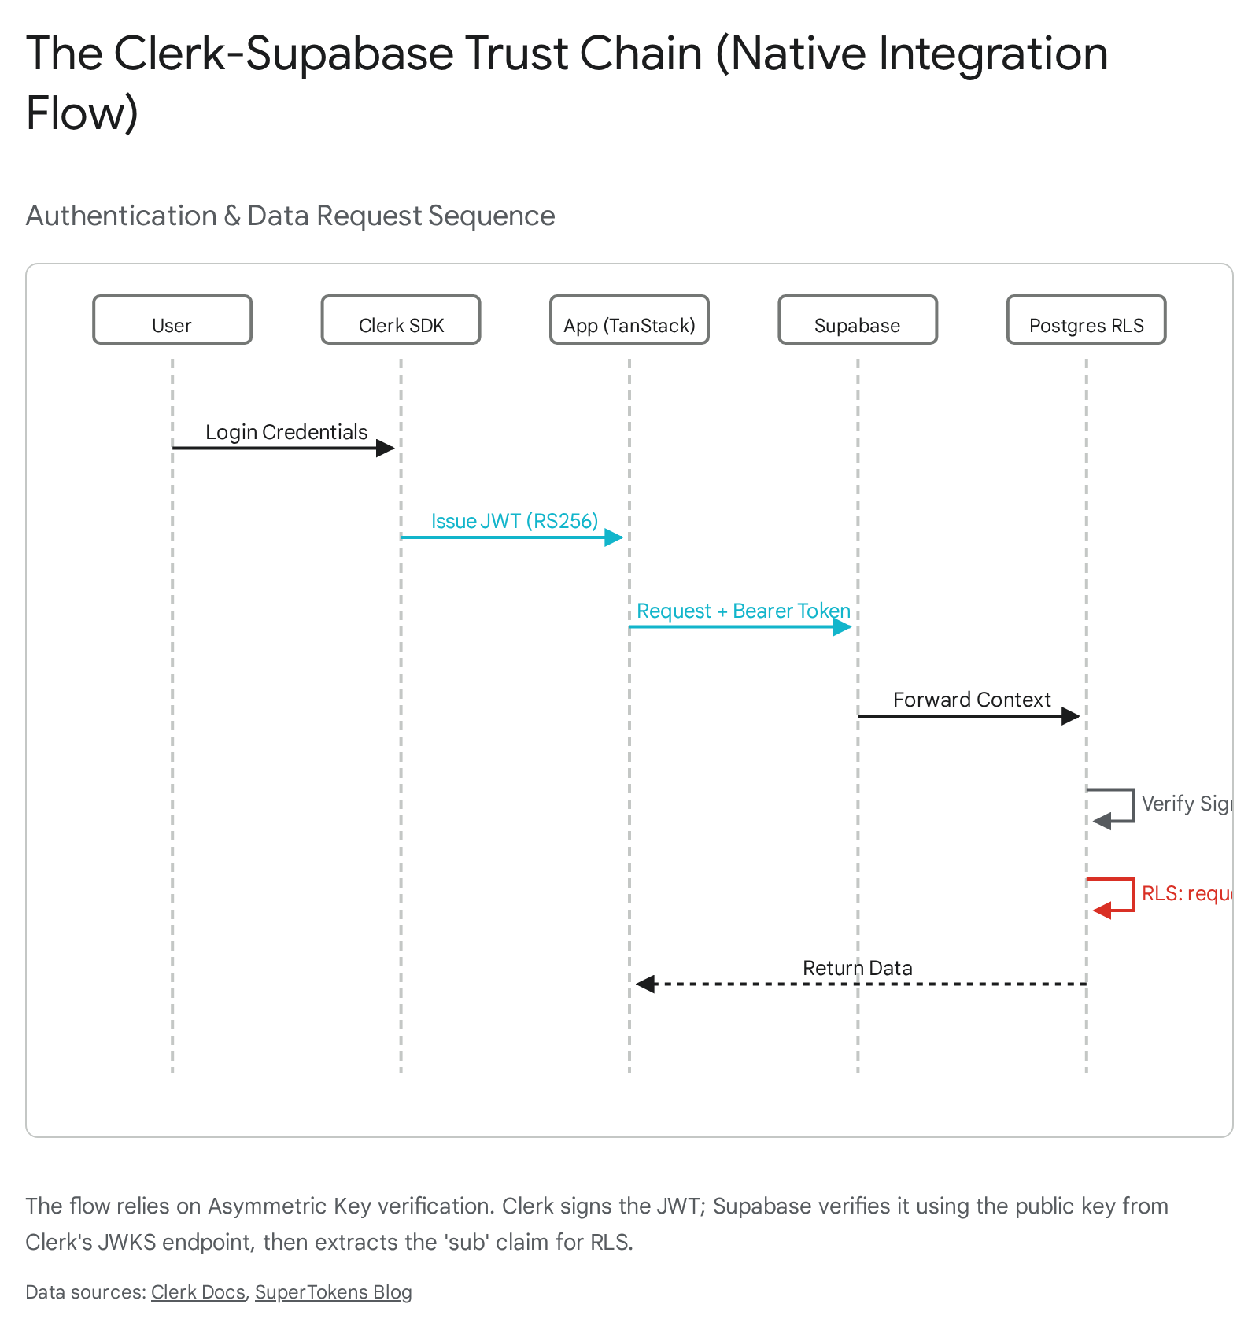

2.2 The Row Level Security (RLS) Interface
While the authentication handshake is secure, a fundamental data type conflict exists at the authorization layer. Supabase's native auth system issues tokens where the user ID is a UUID (e.g., 550e8400-e29b-41d4-a716-446655440000). Consequently, the built-in helper function auth.uid() in Supabase is strictly typed to return a UUID. Clerk, however, generates user IDs as strings (e.g., user_2w2a6PJC...).
This mismatch is a critical architectural friction point. If a developer attempts to use auth.uid() with a Clerk token, the Postgres runtime will throw an "invalid input syntax for type uuid" error, causing all RLS policies to fail.²

The requesting_user_id() Abstraction
To resolve this, the database schema must be adapted to support string-based identifiers for user references. All foreign keys referencing users (e.g., profiles.id, orders.customer_id) should be defined as text or varchar rather than uuid.⁴
Furthermore, the RLS policies must be decoupled from Supabase's internal auth logic. We implement a custom SQL function, requesting_user_id(), which extracts the Clerk Subscriber ID (sub) directly from the JWT claims injected by the PostgREST layer.

SQL

-- Secure extraction of Clerk ID from the JWT
CREATE OR REPLACE FUNCTION requesting_user_id()
RETURNS text
LANGUAGE sql
STABLE
AS $$
SELECT NULLIF(
current_setting('request.jwt.claims', true)::json ->> 'sub',
''
)::text;
$$;
This function reads the request.jwt.claims configuration setting, which is securely populated by the Supabase API gateway after successful token verification.⁵ It is marked STABLE to ensure it is evaluated only once per statement, optimizing performance for complex queries involving multiple RLS checks.
Policy Implementation:
With this abstraction, RLS policies become provider-agnostic. A policy to restrict access to a user's own data would be defined as:

SQL

CREATE POLICY "Enforce User Sovereignty"
ON public.documents
FOR SELECT
USING ( owner_id = requesting_user_id() );
This pattern creates a robust "sovereign identity" layer. Should the architecture require migration to another OIDC provider in the future (e.g., Auth0 or a custom solution), only the requesting_user_id() function would need modification; the thousands of RLS policies protecting table rows would remain untouched.⁶

2.3 Mobile Authentication with Capacitor
Bringing this web-native stack to mobile via Capacitor introduces significant complexity regarding session persistence and the OAuth "handshake." The primary challenge is that Clerk's standard authentication flows rely on browser-based redirects and cookies, which behave inconsistently in the hybrid mobile environment.

The WebView/Browser Dichotomy
In a Capacitor application, the UI runs inside a system WebView (WKWebView on iOS, WebView on Android). However, for security reasons (specifically, Google's "disallowed user agent" policy), social login flows often cannot happen directly inside this WebView.⁷ They must occur in the system browser (Safari/Chrome) or an ASWebAuthenticationSession.
When the user authenticates in the system browser, the session cookie is set in that browser's jar. The Capacitor WebView does not have access to this cookie jar. This leads to a broken state where the user is logged in on Safari but remains unauthenticated in the app.⁹

Deep Linking and the Manual Handshake
The solution requires a rigorous implementation of Deep Linking and a "Manual Handshake" pattern.
- Custom URL Scheme: The Capacitor app must register a custom scheme (e.g., com.myapp://) in the Info.plist (iOS) and AndroidManifest.xml (Android) to allow the operating system to route specific URLs back to the app.¹⁰
- Redirect Configuration: In the Clerk Dashboard, the "Allowed Redirect URLs" must be updated to include this custom scheme (e.g., com.myapp://oauth-callback).
- The Interception Logic:
The application utilizes the Capacitor App plugin to listen for the appUrlOpen event. When the system browser redirects to the custom scheme, the app intercepts the URL, extracts the session token or rotation token appended by Clerk, and manually hydrates the Clerk client session.

TypeScript

import { App } from '@capacitor/app';
import { useClerk } from '@clerk/clerk-react';
// Inside the App initialization logic
const { setActive } = useClerk();
App.addListener('appUrlOpen', async ({ url }) => {
if (url.startsWith('com.myapp://oauth-callback')) {
// Extract the rotation token from the URL parameters
const params = new URL(url).searchParams;
const token = params.get('rotating_token');
if (token) {
// Manually set the active session in the WebView context
await setActive({ session: token });
}
}
});
This "manual handshake" effectively bridges the air gap between the system browser's cookie storage and the app's internal state.¹¹

3. The Modern Frontend: TanStack, State, and Validation
The frontend architecture is constructed to address the primary bottleneck of modern Single Page Applications (SPAs): the "waterfall" of network requests that degrades Time-to-Interactive (TTI). The combination of TanStack Router, TanStack Query, and Zod creates a system where data fetching is decoupled from component rendering and strictly typed at the runtime boundary.

3.1 The "Loader-First" Routing Paradigm
In traditional React architectures (e.g., using react-router-dom v5/6 with useEffect), data fetching is tightly coupled to the component lifecycle. The browser downloads the JavaScript bundle, parses it, renders the component, and only then initiates the network request. This sequential execution results in a cascade of loading spinners and layout shifts known as a "waterfall."
TanStack Router inverts this model by elevating data fetching to the routing layer. When a user intends to navigate (e.g., hovers over a link), the router initiates the data fetch in parallel with the code splitting and route transition logic.¹²

The Shared Query Options Pattern
To implement this efficiently without code duplication, the architecture employs the "Shared Query Options" pattern. The query logic—including the endpoint definition, caching parameters, and validation schema—is encapsulated in a single object that is consumed by both the Router (for prefetching) and the Component (for reactivity).¹⁴

TypeScript

import { queryOptions } from '@tanstack/react-query';
import { z } from 'zod';
// 1. Define the Schema (The Contract)
const ProjectSchema = z.object({
id: z.string(),
name: z.string(),
status: z.enum(['active', 'archived']),
});
// 2. Define the Query Options Factory
export const projectQueryOptions = (projectId: string) => queryOptions({
queryKey: ['projects', projectId],
queryFn: async () => {
const res = await fetch(`/api/projects/${projectId}`);
const data = await res.json();
// 3. Zod Validation at the Runtime Boundary
return ProjectSchema.parse(data);
},
staleTime: 1000 * 60 * 5, // 5 minutes
});
// 4. Router Loader Integration
export const Route = createFileRoute('/projects/$projectId')({
loader: ({ context: { queryClient }, params }) =>
// Seed the cache before the component renders
queryClient.ensureQueryData(projectQueryOptions(params.projectId)),
});
By using ensureQueryData in the loader, the application guarantees that by the time the ProjectComponent mounts and calls useSuspenseQuery, the data is already resident in the cache.¹⁵ This effectively eliminates the "loading state" for the user, creating an instantaneous "app-like" navigation experience.

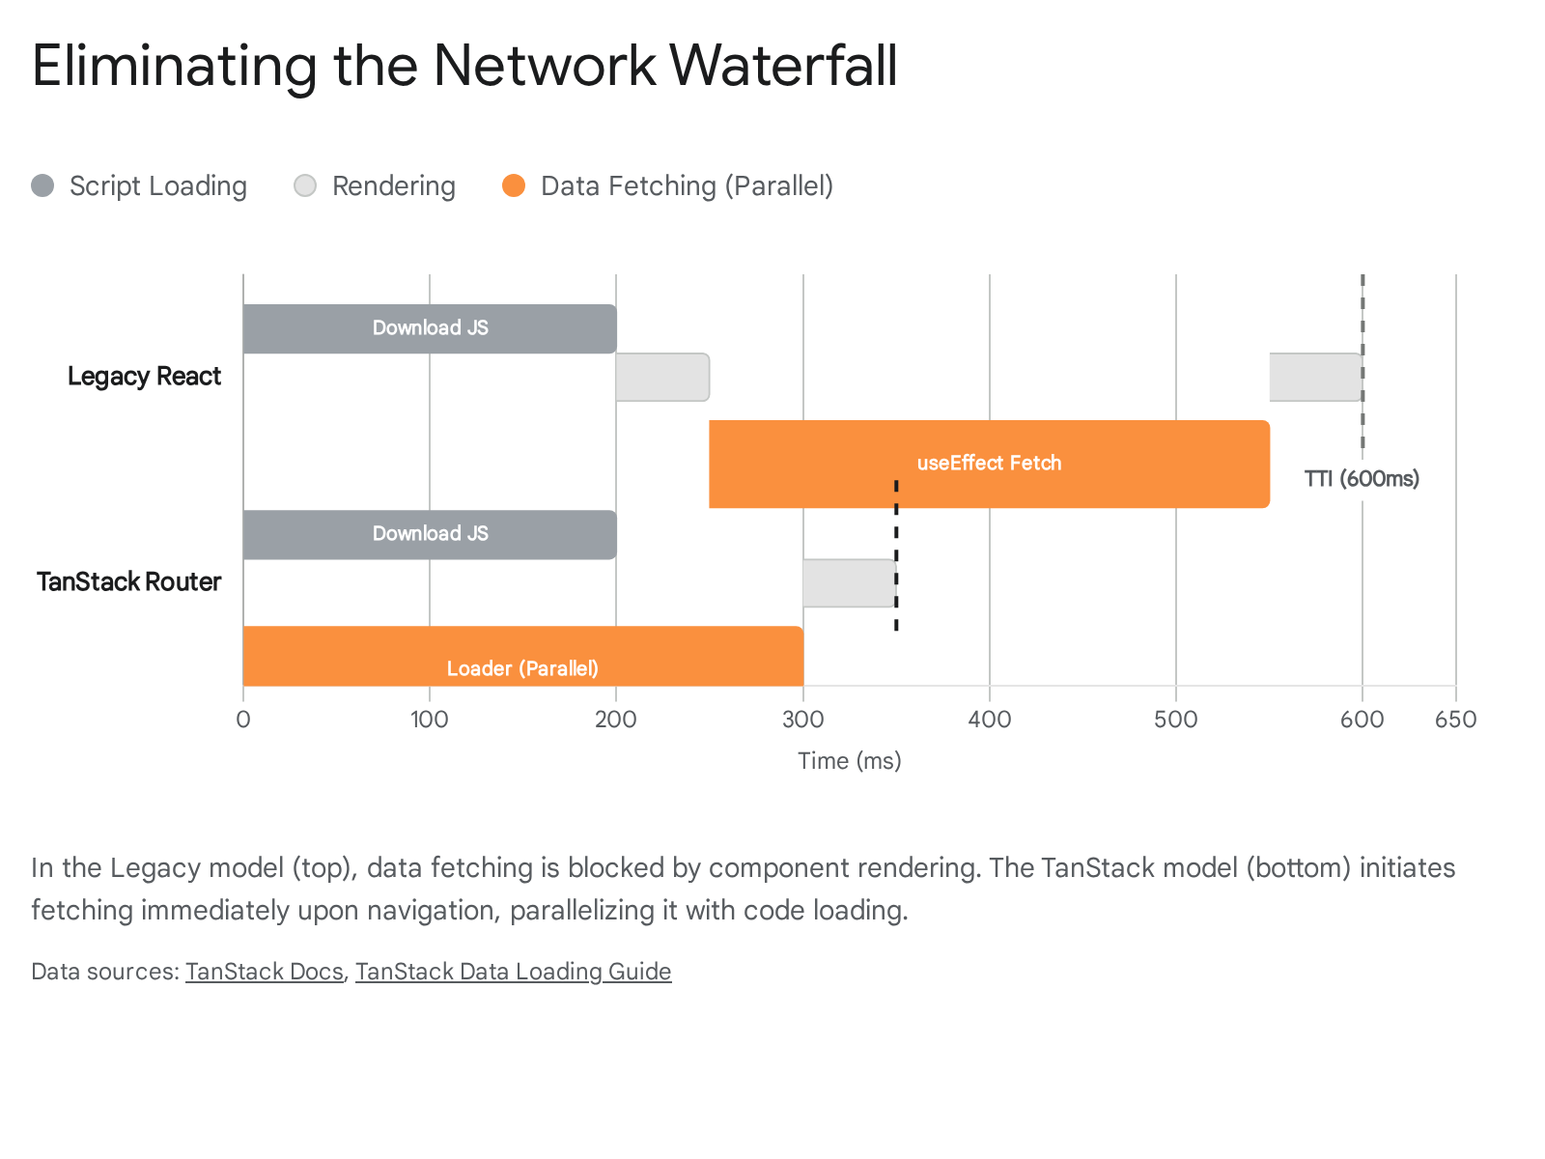

3.2 Zod: The Runtime Enforcer
Zod plays a pivotal role in maintaining system integrity across the frontend and the edge. In a distributed stack where the backend (Supabase/Edge Functions) and frontend are decoupled, TypeScript's compile-time guarantees are insufficient. A schema change in the API can silently break the frontend at runtime.
Zod bridges this gap by enforcing schema validation at the I/O boundary. As demonstrated in the projectQueryOptions above, every API response is passed through ProjectSchema.parse(). If the backend returns malformed data (e.g., a missing required field or an incorrect enum value), Zod throws a descriptive error immediately upon fetch. This fail-fast mechanism prevents the UI from rendering in an undefined state, allowing the application to trigger a graceful Error Boundary rather than crashing with a cryptic "cannot read property of undefined" error deep in the component tree.¹⁶

3.3 Component Architecture: Shadcn and Tailwind
Shadcn/UI provides the component primitives for this stack, but its architectural significance lies in its "distribution model." Unlike traditional component libraries (e.g., MUI or AntD) that are installed as opaque node_modules, Shadcn components are copied directly into the project's codebase.
This approach aligns with the "sovereign" philosophy of the stack. It grants the engineering team full ownership of the component logic and styling, eliminating the "fight against the library" that occurs when customizing pre-bundled components. Tailwind CSS acts as the atomic styling engine, ensuring that these components are lightweight and that unused styles are purged at build time, contributing to the performance goals set by the TanStack layer.

4. Edge Compute and API Gateway: Netlify and Supabase
The architecture utilizes two distinct "Edge" runtime environments: Netlify Edge Functions and Supabase Edge Functions. While both utilize the Deno runtime and support standard Web APIs, they serve fundamentally different roles within the system topology.

4.1 Netlify Edge Functions: The Ingress Gateway
Netlify Edge Functions are deployed to the Content Delivery Network (CDN) nodes closest to the user. Their primary role is Ingress Control—intercepting, modifying, or routing HTTP requests before they reach the core application logic or static assets.¹⁷

The R2 Proxy Pattern
A critical use case for Netlify in this stack is acting as a secure proxy for Cloudflare R2 assets. Directly exposing an R2 bucket to the public internet requires managing complex CORS configurations and potentially exposing bucket details. A more secure and performant pattern involves keeping the R2 bucket private and routing asset requests through a Netlify Edge Function.
- Request Interception: The client requests an asset, e.g., /api/assets/user-avatar.png.
- Auth Verification: The Edge Function inspects the request headers for the Clerk session cookie. Because the function runs on the same domain as the app, it has access to first-party cookies.
- Signing & Fetching: If the user is authorized, the function uses the aws4fetch library (compatible with Deno) to sign a request to the private R2 bucket using the stored access keys.¹⁸
- Streaming Response: The function streams the response body from R2 directly to the client. Crucially, it does not buffer the entire file into memory; it pipelines the ReadableStream from the R2 response to the client response.¹⁹
This pattern provides fine-grained access control to static assets without burdening the primary application server or exposing storage credentials.

4.2 Supabase Edge Functions: The Logic & Data Layer
Supabase Edge Functions are deployed regionally, typically co-located with the Postgres database. Their primary role is Data Logic—handling webhooks, database triggers, and heavy computational tasks that require low-latency access to the database.²⁰

Secure Webhook Verification (Stripe)
Handling webhooks from payment providers like Stripe requires precise cryptographic verification. This presents a specific challenge in the Deno environment used by Supabase. Stripe's signature verification algorithm requires the raw, unparsed request body.
If a developer attempts to parse the request as JSON (req.json()) before verification, the runtime may normalize whitespace or key ordering, altering the payload's hash and causing verification to fail. The correct pattern in Supabase Edge Functions is to read the body as a generic text stream or ArrayBuffer first:

TypeScript

// Supabase Edge Function for Stripe
import { serve } from "https://deno.land/std@0.168.0/http/server.ts";
import Stripe from "https://esm.sh/stripe?target=deno";
serve(async (req) => {
const signature = req.headers.get("Stripe-Signature");
// Critical: Read raw body as text for verification
const body = await req.text();
try {
const event = await stripe.webhooks.constructEventAsync(
body,
signature,
Deno.env.get("STRIPE_WEBHOOK_SECRET")
);
// Proceed with logic using JSON.parse(body) if needed
} catch (err) {
return new Response(err.message, { status: 400 });
}
});
This nuance is critical for ensuring payment security and preventing replay attacks.²¹

Shared Code Strategy (Monorepo)
Since both the Frontend and the Edge Functions use TypeScript, the architecture supports a powerful code-sharing strategy. By utilizing a monorepo structure (e.g., Turborepo or simple workspaces), developers can define Zod schemas in a shared package (e.g., packages/shared). These schemas can be imported into the Supabase Edge Functions via the deno.json import map, pointing to the local file system or a private registry.²² This ensures that the validation logic used by the API to process a payment is identical to the logic used by the frontend to validate the form, eliminating "drift" between client and server validation rules.

5. Data Architecture: The Transactional-Analytical Split
A defining characteristic of high-performance modern applications is the separation of "Hot" (Transactional) and "Cold" (Analytical) data. This architecture leverages the synergy between Supabase (Postgres) and Cloudflare R2 via Apache Iceberg to prevent the common scaling pitfall where analytics queries degrade application performance.

5.1 The Limits of the Postgres Heap
Postgres utilizes a heap storage engine optimized for OLTP (Online Transaction Processing) workloads—specifically, high-concurrency INSERT, UPDATE, and SELECT operations on specific rows. However, it is inefficient for OLAP (Online Analytical Processing) queries that need to scan millions of rows to aggregate data (e.g., "Calculate the average revenue per user over the last year"). Such queries force the database to scan the heap, consuming massive amounts of I/O and CPU, which can slow down or lock the database for transactional users.

5.2 The Iceberg Lakehouse Architecture
To solve this, the stack employs an Iceberg Lakehouse pattern. Supabase's "Analytics Buckets" allow data to be stored in the Apache Iceberg table format within Cloudflare R2 object storage.²³
Mechanism:
Iceberg organizes data into Parquet files. Parquet is a columnar storage format, meaning data is stored by column rather than by row. This allows for extreme compression and efficiency for analytical queries. If a query only requests the revenue column, the engine only reads the data blocks associated with revenue, ignoring the rest of the row data.
The Economic Advantage:
The choice of Cloudflare R2 is driven by its Zero Egress Fee model. In a standard AWS S3 setup, querying data from an external analytics engine would incur significant egress charges for every gigabyte read. R2 eliminates this cost, making it economically viable to store terabytes of log data and query it frequently.24

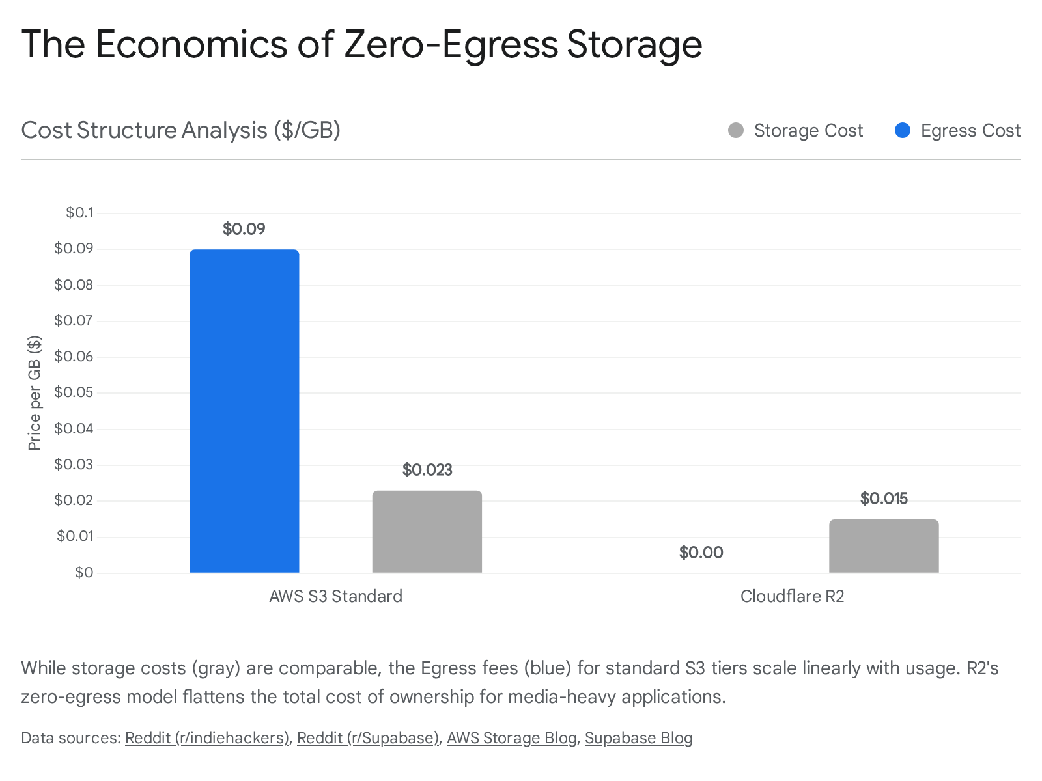

5.3 Unified Querying via Foreign Data Wrappers (FDW)
The integration is seamless thanks to Postgres Foreign Data Wrappers (FDW). The architecture does not require a separate ETL tool or analytics dashboard connection. Instead, the Iceberg store is mounted directly into the Postgres database as a Foreign Table.
From the developer's perspective, querying the "Cold" data looks exactly like querying a standard Postgres table:
SELECT * FROM analytics.logs WHERE event_type = 'login';
Under the hood, the Postgres engine translates this SQL query into calls to the Iceberg connector. This connector accesses the R2 bucket, reads the metadata to find the relevant Parquet files, fetches only the necessary column chunks, and returns the result to Postgres. This "Lens" architecture allows the application to maintain a single SQL interface for all data, while physically routing the heavy analytical I/O to the cost-effective object storage layer, preserving the performance of the primary transactional node.²⁵

6. The Visual and Interactive Plane: Motion and ThorVG
The visual layer of the stack is designed for high-performance rendering and spatial continuity, leveraging Motion for React and ThorVG.

6.1 ThorVG: The Next-Generation Vector Engine
For years, Lottie (using the lottie-web player) has been the standard for web animations. However, lottie-web is a heavy JavaScript dependency that relies on the HTML5 Canvas 2D or SVG context, which can be performance-intensive on mobile devices.
ThorVG enters this stack as a superior alternative. It is a lightweight, portable vector graphics library written in C++, which is compiled to WebAssembly (WASM) for the web.
- Binary Efficiency: The ThorVG runtime is approximately 150KB, significantly smaller than the typical Lottie player bundle, reducing the JavaScript payload.²⁶
- DotLottie Format: ThorVG natively supports the .lottie file format. This format is a zip archive that compresses the JSON animation data and bundles external assets (images, fonts). This optimization can reduce the network payload by up to 80% compared to raw JSON Lottie files.
- Rendering Pipeline: ThorVG is optimized for SIMD (Single Instruction, Multiple Data) and can leverage GPU acceleration (WebGPU/WebGL), making it highly performant for the constrained environments of mobile WebViews in Capacitor.²⁶

6.2 Synchronized Scroll-Linked Animations
A powerful interaction pattern enabled by this stack is the synchronization of vector animations with user scroll, creating immersive "Scrollytelling" experiences. This is achieved by bridging Motion for React with ThorVG.
Motion's useScroll hook provides a reactive value (scrollYProgress) representing the user's scroll position between 0 and 1. The architecture links this value to the frame seek function of the ThorVG player.

TypeScript

import { DotLottieReact } from '@lottiefiles/dotlottie-react';
import { useScroll, useMotionValueEvent } from 'motion/react';
import { useState } from 'react';
export const ScrollAnimation = () => {
const { scrollYProgress } = useScroll();
const = useState(null);
useMotionValueEvent(scrollYProgress, "change", (latest) => {
if (dotLottie) {
// Map scroll progress (0-1) to total animation frames
const frame = Math.round(latest * dotLottie.totalFrames);
dotLottie.seek(frame);
}
});
return (
<DotLottieReact
src="/animation.lottie"
dotLottieRefCallback={setDotLottie}
autoplay={false} // Critical: We control playback manually
/>
);
};
By disabling autoplay and manually seeking frames based on the Motion value, the animation scrubs forward and backward in perfect sync with the user's gesture. ThorVG's efficient rasterizer ensures this scrubbing is buttery smooth, even at high frame rates.²⁷

7. Intelligence and Localization: OpenAI, DeepL, and Structured Data
The final layer of the stack integrates Artificial Intelligence (OpenAI) and automated localization (DeepL). The architectural focus here is on determinism and type safety.

7.1 OpenAI Structured Outputs with Zod
Integrating Large Language Models (LLMs) into applications often introduces "fuzzy" data risks—the model might return invalid JSON, missing fields, or incorrect types. To mitigate this, the stack employs Zod as the schema definition layer for OpenAI's "Structured Outputs" (Function Calling).²⁹
The workflow enforces strict typing:
- Schema Definition: The developer defines the desired output structure using Zod (e.g., RecipeSchema).
- Schema Conversion: A utility library (like zod-to-json-schema) converts the Zod object into a JSON Schema strictly compatible with OpenAI's API specs.
- Strict Mode: The schema is passed to OpenAI's API with the strict: true flag, forcing the model to adhere exactly to the definition.
- Validation: Upon receiving the response, the application parses the JSON result back through the Zod schema (RecipeSchema.parse()).
This end-to-end validation pipeline guarantees that the AI integration never introduces runtime errors into the frontend application. If the model hallucinates a field or returns a string instead of a number, Zod intercepts the error at the data boundary.³⁰

7.2 DeepL for Dynamic Localization
For global applications, DeepL is integrated into the content pipeline. Rather than manual translation files, the architecture can support an "Edge Translation" pattern.
- Workflow: Content stored in the database (Supabase) is passed through a Supabase Edge Function triggered by an INSERT or UPDATE event.
- Translation: The function calls the DeepL API to generate translations for supported locales.
- Storage: The translated strings are stored back into the database in a translations JSONB column or a separate table.
- Delivery: The frontend fetches the content based on the user's locale, which is detected at the Netlify Edge layer and passed via headers.

8. Conclusion: The Sovereign Stack
The technology stack detailed in this report—anchored by TanStack, Supabase, and Clerk—represents a paradigm shift in modern web development. It rejects the convenience of the monolithic "walled garden" in favor of a Federated Full-Stack that optimizes for performance, cost, and developer control.
By decoupling identity from the database, the architecture gains best-in-class security features and regulatory compliance. By decoupling data fetching from component rendering via TanStack Router, it achieves a class of performance previously reserved for native applications. And by leveraging the "Cold/Hot" data split with Iceberg and R2, it ensures that the application can scale to petabytes of data without bankrupting the organization on storage fees.
While the initial configuration complexity is higher—requiring precise setup of OIDC trusts, deep links, and edge proxies—the result is an infrastructure that is resilient, globally distributed, and strictly typed from the database disk to the pixel on the screen. This is a foundational architecture built to endure the evolving demands of the next half-decade of software engineering.

Works cited
- Development: Integrate Supabase with Clerk, accessed January 15, 2026, https://clerk.com/docs/guides/development/integrations/databases/supabase
- How to Integrate Clerk with Supabase (Plus another option for the curious) - SuperTokens, accessed January 15, 2026, https://supertokens.com/blog/how-to-integrate-clerk-with-supabase
- Third-party auth | Supabase Docs, accessed January 15, 2026, https://supabase.com/docs/guides/auth/third-party/overview
- supabase RLS with clerk #33091 - GitHub, accessed January 15, 2026, https://github.com/orgs/supabase/discussions/33091
- Clerk | Works With Supabase, accessed January 15, 2026, https://supabase.com/partners/integrations/clerk
- User IDs as strings instead of UUIDs for external auth? · supabase · Discussion #4954, accessed January 15, 2026, https://github.com/orgs/supabase/discussions/4954
- Security | Capacitor Documentation, accessed January 15, 2026, https://capacitorjs.com/docs/guides/security
- OAuth with Capacitor - Privy Docs, accessed January 15, 2026, https://docs.privy.io/recipes/capacitor-oauth
- iOS WebView Redirects to Safari After Clerk Authentication - Production vs Development Issue - Capacitor - Ionic Forum, accessed January 15, 2026, https://forum.ionicframework.com/t/ios-webview-redirects-to-safari-after-clerk-authentication-production-vs-development-issue/248720
- Deep Links | Capacitor Documentation, accessed January 15, 2026, https://capacitorjs.com/docs/guides/deep-links
- Building a Mobile App with Ionic, Vue, and Clerk - DEV Community, accessed January 15, 2026, https://dev.to/aaronksaunders/building-a-mobile-app-with-ionic-vue-and-clerk-1dkl
- Overview | TanStack Router React Docs, accessed January 15, 2026, https://tanstack.com/router/latest/docs
- Data Loading | TanStack Router React Docs, accessed January 15, 2026, https://tanstack.com/router/v1/docs/framework/react/guide/data-loading
- useLoaderData vs useSuspenseQuery · TanStack router · Discussion #1563 - GitHub, accessed January 15, 2026, https://github.com/TanStack/router/discussions/1563
- TanStack Query Integration | TanStack Router Docs, accessed January 15, 2026, https://tanstack.com/router/latest/docs/integrations/query
- Share Zod Validation Schemas Between Repositories | by Mike Chen - Bits and Pieces, accessed January 15, 2026, https://blog.bitsrc.io/share-zod-validation-schemas-between-repositories-8f9ec5fa3ae7
- Edge Functions overview | Netlify Docs, accessed January 15, 2026, https://docs.netlify.com/build/edge-functions/overview/
- aws4fetch · Cloudflare R2 docs, accessed January 15, 2026, https://developers.cloudflare.com/r2/examples/aws/aws4fetch/
- A Deep Dive into Netlify Edge Functions, accessed January 15, 2026, https://www.netlify.com/blog/deep-dive-into-netlify-edge-functions/
- Edge Functions | Supabase Docs, accessed January 15, 2026, https://supabase.com/docs/guides/functions
- Handling Stripe Webhooks | Supabase Docs, accessed January 15, 2026, https://supabase.com/docs/guides/functions/examples/stripe-webhooks
- Managing dependencies | Supabase Docs, accessed January 15, 2026, https://supabase.com/docs/guides/functions/dependencies
- Introducing Analytics Buckets - Supabase, accessed January 15, 2026, https://supabase.com/blog/introducing-analytics-buckets
- Moved from Supabase Storage to Cloudflare R2. : r/indiehackers - Reddit, accessed January 15, 2026, https://www.reddit.com/r/indiehackers/comments/1ou24iv/moved_from_supabase_storage_to_cloudflare_r2/
- Query with PostgreSQL | Supabase Docs, accessed January 15, 2026, https://supabase.com/docs/guides/storage/analytics/query-with-postgres
- thorvg/thorvg: An open-source C++ vector graphics engine supporting SVG and Lottie formats, featuring advanced rendering backends such as WebGPU for high-performance graphics. - GitHub, accessed January 15, 2026, https://github.com/thorvg/thorvg
- @lottiefiles/dotlottie-react - npm, accessed January 15, 2026, https://www.npmjs.com/package/@lottiefiles/dotlottie-react
- Hey :), Can you help me out, I need to make a Lottie animation play as I scroll. | Framer, accessed January 15, 2026, https://www.framer.community/c/developers/hey-can-you-help-me-out-i-need-to-make-a-lottie-animation-play-as-i-scroll
- Structured model outputs | OpenAI API, accessed January 15, 2026, https://platform.openai.com/docs/guides/structured-outputs
- Using Zod with OpenAI Functions - Fardeem Munir, accessed January 15, 2026, https://www.fardeem.com/notes/using-zod-with-openai-functions

